**The Secrets to Successful Referral Programs**

Without question, one of the best sources of bringing new caregivers into the BRI Care Consultation program is a strong referral program. Organizations that are most successful in delivering Care Consultation and similar caregiver support programs are those that enjoy an ongoing flow of new clients that are referred to them through internal or external healthcare resources, social service organizations, professional associations and community-based organizations that service similar populations.

Therefore, developing successful referral relationships is something that organizations delivering Care Consultation should certainly devote some time and attention to. Developing referral relationships can be a challenging process, though. They’re rarely achieved in a single mailing or phone call. In fact, there are a few things that sites looking to build strong referral relationships should keep in mind:

* Building successful referral relationships takes time!
* Referral relationships require personal contact with the other site or professional
* The relationship needs to be maintained and nurtured
* The referring organization needs to feel confident in recommending your program

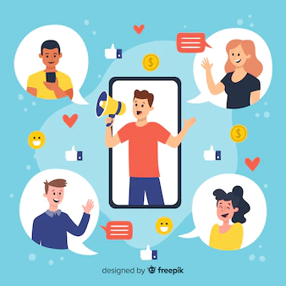

Successful referral relationships are often a two-way street, with both parties providing something of value to the other. And once they are established, the relationship needs to be nurtured. All businesses experience staff turnover, and even long-term staff members receive an influx of messages and new information all the time. To keep your program relevant you need to maintain contact and communication on an ongoing basis. (See p. 14 – Keeping Your Relationships Fresh)

**Building your successful strategy – target the right partners**

The first step in planning your referral strategy is to target appropriate partners in your area. Make a list of healthcare or community organizations, social service and government agencies that service your desired population. Make this a priority; don’t stop at a few agencies you happen to know. Make the list as long as you can. They will likely include:

**Healthcare facilities**

* Hospital geriatric centers, neurology departments
* Hospital and rehabilitation discharge departments
* Screening and diagnostic facilities
* Geriatricians and general practitioners
* Private practice neurologists, oncologists, etc.
* Home health care agencies

**Senior-focused facilities**

* Senior day/activities centers
* Assisted living facilities

**Other groups:**

* Caregiver support groups
* Area Agency on Aging offices
* State or regional offices on aging
* Alzheimer’s or other disease-specific associations
* Home delivered meal programs
* Sites offering exercise/diet/health education for older adults

**Approaching potential referral partners**

As possible, research leadership and staff members at these organizations and collect names and any contact information available. That will help determine the vehicles you can use to approach them. If nothing else, a generic info@ email address is better than nothing. It’s usually best to use a variety of contact methods, as people have varying preferences in how they like to communicate.

**A single contact is almost never enough.** It may take several tries before the partner is willing to talk to you. Just because they don’t respond to your first outreach doesn’t mean they’re not interested, perhaps just busy. There will be organizations that simply don’t want to partner, but don’t give up on a potentially lucrative site without a few attempts.

**A personal visit:** Of course, this is the most resource- and time-intensive method, but it’s also the most effective. You’ll want to use this technique with sites that offer the most potential referrals or where you have an existing relationship with staff members. Of course, an unannounced “drop-in” isn’t appropriate for all sites, but it may work for a doctor’s office or senior center, where the receptionist can also help to direct you to the proper staff members. You may also want to set an appointment for an in-person visit with people you’ve been in contact with through other channels.



**Email communication:** Email is a highly acceptable form of soliciting business. In fact, many people prefer to communicate electronically. Of course, it often takes several tries to get someone to open and read an email. If you’re using a mass email system you can easily tell who has opened your correspondence and who has clicked links that you’ve included to provide more information. Many other email platforms offer a Read Receipt feature that prompts readers to let you know that they’ve opened the email.

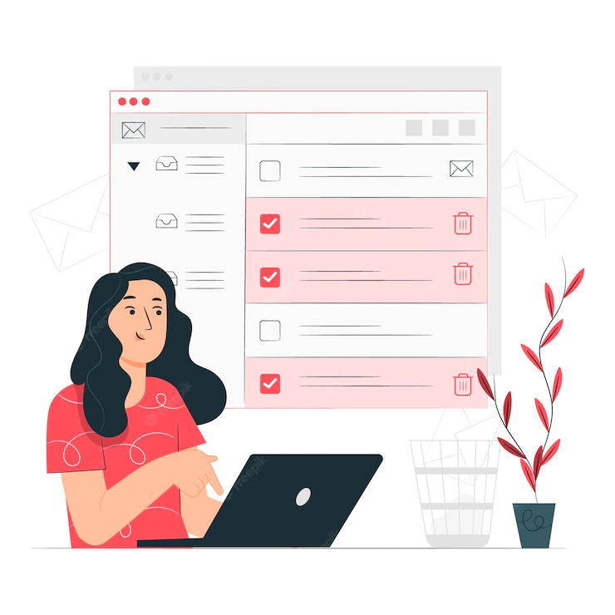

One of the benefits of email is to offer people with even moderate interest in your offer the opportunity to easily reply back to you. Make sure your email contains a simple and straightforward offer that they can accept with little effort – often an electronic brochure to find out more about your program is very effective.



**Telephone:** It’s true that many people don’t especially like talking on the phone. But the phone is still a highly effective way to make contact with a new potential partner. It’s especially effective in following up on an email or letter that’s been sent. Even if the result is a voicemail, it still carries the benefit of adding a personal, friendly voice to your organization, and added attention to your message.

**Letter:** Especially with the massive decline in the volume of mailed correspondence, letters can actually be a highly effective tool for introducing your program to referral sources. However, just be sure to make the letter short and to the point.



If at all possible, personalize it to the individual receiving it. Put the letter on letterhead, sign it yourself, and put it in an envelope with a real stamp on it. Hand-writing the address on the envelope gets it opened even more often.

Since you cannot offer the recipient an easy way of responding back to you, a follow-up phone call is highly encouraged. (See sample on p. 17)

**Postcard mailings:** Postcards are a popular choice among many agencies because they’re easy to create, fairly low in cost and can be mailed in bulk at a lower rate. There’s also some value in the message being immediately visible without having to open an envelope. Unfortunately, postcards have a poor response rate. They are rarely effective in being memorable enough to spur action and are frequently not taken seriously by the recipient. A personal letter typically generates more interest.

**Indirect Referral Approaches**

While you’re certainly welcome to approach referral sites with a direct request for referrals, another strategy can be to approach the agency or facility with something of value that they appreciate and can use, even if it’s not directly associated with the program you offer. These types of tactics can offer a low-impact method of beginning a relationship.

Here are a few tactics to try:

Offer them a Lunch & Learn about a topic of interest to their staff or to their population. Make sure the topic is educational (not just a program pitch) and of interest to a wide audience. If it’s well received, do it again. Leave behind informational documents they can pass out. Become a valued resource to the staff before suggesting a referral arrangement.

1

Offer one or more in-person or virtual sessions where you provide their clients with a free individual assessment, or group Q&A session where they can ask your Care Consultants or Case Managers questions about some of the services provided by your program. Care Consultants can demonstrate how they go about finding the right resources or solutions to meet their needs.

2

3

Offer a reciprocal referral for them. Agree to refer your program clients or intake calls to one or more of their programs in exchange for their referrals to yours. This, of course, will require that you vet their programs to assure you’re comfortable in sending clients their way.

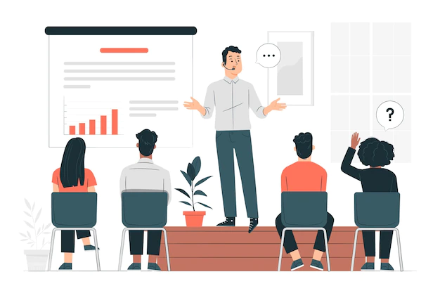

**Form relationships with your referral partners!**

Once a referral partnership has been established, the key to keeping it successful is to have an ongoing relationship with the partner. That means you need to do what it takes to nurture the relationship and keep it relevant in the minds of staff and management at your partner organization. Personal contact, freshened materials, and offers of joint activities help to keep referrals flowing.

“We have several relationships with doctor’s offices, and we make sure that we stop in on a regular basis, sometimes bringing treats to the staff,” says the director of one successful Care Consultation site. “And just to be clear, having a relationship with the doctor’s office doesn’t necessarily mean the doctor – it’s often the office manager or the nurse who actually hands out the brochures rather than the doctors themselves.”

Remember, people will be more comfortable in referring a program to their clients when they know the people behind it and have confidence in the effectiveness of the solution.

Keep the handout materials you provide them simple. They don’t need too much information or “sales” messages. The goal of materials is to give basic program information that may relate to a caregiver/care receiver in need and encourage them to call to find out more. Keep the referral process easy for your partners to understand. Simplicity will allow them to feel confident in referring the program, without fear of forgetting or misrepresenting complicated details.

**Don’t forget your internal referrals, too**

Many sites fail to take full advantage of their existing clients already participating in the other programs and services within their organization. Internal training sessions for staff in other departments are crucial to enabling them to refer clients to Care Consultation.

In addition to immediate referrals, it’s important that other client-facing staff members are provided with written materials about the program that they can distribute. Potential clients may not be in need of the services now, but may save the brochure, or at least remember the program exists should the need arise in the future.

**Networking**

Yes, that dreaded word. Networking is intimidating to almost everyone. It’s tough to put yourself out there, meet new people, and (possibly) feel rejected.

But it really does work. As the saying goes, you don’t know what you don’t know. Or who, in this case.

All communities have networking groups. Some are affiliated with Chambers of Commerce, some cities have small business groups, and there are always Rotary clubs and profession-specific groups to join. Some offer opportunities for two-minute talks or even “speed-dating” introductions to your organization.

The key to networking is, again, to not give up. It’s unlikely that your next referral partner is going to be in the crowd on your first time out. They may not be there at all. Chances are your new partner will be the wife of someone in the group, or their neighbor or their uncle. It’s about having conversations and simply connecting the dots as they’re presented.

The introduction, then, to the potential referral partner is much easier with the endorsement of the third party. The connection has already been established and their interest aroused before you even meet.



**Referrals from a medical or health facility**

The Holy Grail of all referral relationships for caregiver support programs is to maintain ongoing, active referrals from a medical or health facility that specializes in dementia, gerontology or other aging-related conditions and services.

Recommendations from physicians and medical staff are regarded with respect, and their suggestions carry an implied endorsement that is often taken very seriously by their patients and caregivers.

Unless you’re fortunate enough to have an existing organizational relationship with a hospital or medical center, forming a relationship can take considerable time and effort, and may even seem insurmountable.

But here’s a tactic that worked for WeCare. . . Because You Do, the service delivery arm of BRI Care Consultation for Benjamin Rose Institute on Aging. Instead of approaching the department president or administrator, find a single doctor within the hospital or practice that has an interest in your program.

“We are currently enjoying a very successful referral relationship with a Gerontologist at one of the most respected medical facilities in the world,” says Lisa Weitzmen, Director of Strategic Partnerships at Benjamin Rose Institute on Aging. “Had we tried to approach him to provide referrals for the whole department we likely would have been blocked by red tape. But by approaching and forming a relationship with this one very well-respected doctor and suggesting he send his appropriate patients to us, he has spread the word throughout the department and we are enjoying new care consultation referrals on a daily basis.”

There are a number of ways to meet and form relationships with medical professionals. Rule #1 is patience! It takes time; don’t expect it to happen overnight. Here are some ways to begin the process.

**Current clients:** Oftentimes, a program’s biggest and most vocal supporters come from clients themselves, or family members of clients. People are more likely to be invested in your program or service if they have experience with the particular area it addresses. If someone is a caregiver to a parent with dementia, they will likely be more appreciative of programming that addresses the issues they personally experienced. Getting to know the families of clients enrolled in your programs can yield not only positive word-of-mouth recommendations, but can occasionally uncover opportunities for professional referral sources too.

**Target and approach them:** If there is a medical facility that stands out in your community, or a dementia- or aging-specific organization, familiarize yourself with the medical professionals on staff there. Select a few of the most established ones and begin a dialogue. Send them a personal letter, invite them to an event. If possible, send them voicemails or emails. Let them know you have a program that could greatly benefit their patients that you’d love to share with them.

**Embed yourself as a resource within a healthcare environment**

Maintaining a presence as a helpful community resource within a medical clinic, hospital or aging services agency can be one of the most positive and proactive ways to generate a steady stream of referrals.

It only makes sense – as medical appointments are conducted, older adults and, frequently, their caregivers find themselves seeking solutions to both new and existing issues. Your staffed, in-person desk embedded within a health center can help to provide information to these care teams about programs available to help them.

You can incorporate referral forms and even sign-up forms to your programs, as appropriate, and certainly encourage them to consider your Care Consultation program. Through one-on-one conversations you will likely be more successful at providing a more comprehensive understanding of the program than is possible through a brochure alone.

If desired, you can even set an appointment for the first follow-up call to take place and provide the clients with an appointment card and reminder text.

*Example:* WeCare…Because You Do, the service delivery arm of BRI Care Consultation operated through Benjamin Rose Institute on Aging, has established a partnership with an office of a local health system to maintain a physical presence at one location for several hours three days per week.

Staffed by WeCare employees, the office refers many individuals who become WeCare clients, as well as connecting them with other services offered by Benjamin Rose.

”It took us two years to form the relationship with this establishment and to create the partnership we enjoy today, but it was certainly well worth the effort,” says Weitzman of Benjamin Rose Institute on Aging.

**Referrals from Police and EMS Departments**

One interesting and potentially rewarding source of referrals for your caregiver support program can be your local Police Department or Fire Department’s emergency medical services. These professionals come into contact with older adults with chronic illnesses on a regular basis and are in an ideal position to identify individuals and families who would benefit from care-coaching services. In fact, many would welcome the opportunity to provide follow-up help to the people they meet during their times of crisis.

In Ohio, the Summit County Health Department has established relationships with several Fire Departments in the county, which can account for a significant number of referrals.

“We had about 15 referrals over the Labor Day weekend from our EMS partnerships,” said one of their Licensed Social Workers. “We started the relationship by doing Dementia Friends training for the local police and fire departments and extended into our caregiver programs.”

Many of the referrals received from the EMS departments are appropriate for Care Consultation, she notes, and others are often directed to Summit’s other caregiver program.

A good approach to your local Fire and Police Departments is with a training offer. Dementia Friends training or a Powerpoint with a similar content is a wonderful and often welcome opportunity for them to understand how to better deal with people they encounter who are living with dementia.

Training can also be conducted to help them identify caregivers who are struggling to provide effective care, older adults with significant unmet needs, and recognizing the signs of people with cognitive issues.

**Planning your approach to other agencies for referrals**

As you plan your outreach to establish referral relationships with partner organizations, it’s important to be prepared to help them understand the benefits they, too, will derive from offering Care Consultation to their clients. Here are a few examples, by type of referral partner, of potential benefits your program could provide them.

**Care Consultation benefits for Home Health Agencies**

* Helps older adults remain in their homes longer
* Deepens the care relationship with your clients
* Facilitates better in-home care by providing information and resources
* Identifies other needs related to health care concerns
* Enables aides to focus on necessary care tasks
* Increases overall satisfaction with your services
* Proven to reduce hospital readmissions and ER visits
  + One fewer hospital readmission, on average
  + 50% reduction in Emergency Room visits

**Benefits for Discharge Planning personnel**

* Proven to reduce hospital readmissions and ER visits
  + One fewer hospital readmission, on average
  + 50% reduction in Emergency Room visits
* Provides solutions to prevent ER/hospital visits
* Provides information and resources to support the discharge plan and better care at home
* Identifies needs related to health care concerns
* Helps older adults remain in their homes longer
* Deepens the care relationship with clients

**Benefits for Geriatricians/Physicians**

* Improves patient’s ability to access needed community services and resources
* Increases families’ understanding of diagnoses and appropriate care
* Identifies other needs related to health care concerns
* Reduces the number of non-essential appointments
* Helps older adults remain in their homes longer
* Proven to reduce hospital readmissions and ER visits
  + One fewer hospital readmission, on average
  + 50% reduction in Emergency Room visits

**Benefits for Home Delivered Meals programs**

* Provides information/resources for better care at home
* Identifies other needs related to nutrition and health
* Helps older adults remain in their homes longer
* Improves ability to access needed community services and helps identify other support systems
* Deepens the care relationship with your clients
* Proven to reduce hospital readmissions and ER visits
  + One fewer hospital readmission, on average
  + 50% reduction in Emergency Room visits

**Keeping your relationships fresh – in-person ideas**

Help keep your program on the minds of employees at your partner organizations. Visit them, email them with news and updates, provide them with useful information. Ongoing contact is crucial to ongoing trust.

**In-person contact ideas**

Sometimes it’s possible to visit your partner in person – smaller agencies, doctor’s offices, adult day centers typically have client-facing staff members who are accessible during the day and may appreciate your outreach.

* Say thank you for referrals they’ve sent to you with food! Deliveries of bagels or muffins in the morning as a thank-you for their help are always appreciated, especially trays of goodies that can be shared with the entire staff. Afternoon cookie or brownie trays are rarely turned away. Make sure to include your card within the tray so everyone knows who they’re from
* Drop in to deliver a fresh supply of updated brochures or flyers for them to hand out to clients
* Personally invite staff members or agency leaders to your next seminar, webinar or educational session, and deliver them their own invitation.
* Deliver flyers inviting their clients to your next webinar or seminar



**Keeping the relationship fresh - written or remote communications**

It’s not always feasible to visit your referral partners. You may be short on time, or they may not be easily accessible during business hours. Maintain written or telephone communication with them to show your appreciation is just as important in keeping your program relevant.

* Ask staff members or agency leaders to participate as a speaker or on a panel in your next educational session, webinar or lunch & learn. Getting them more involved in your organization can only help to solidify their commitment to your programs
* Send them useful articles or videos you’ve identified that they may find interesting or helpful, like new research studies, news about local organizations, etc.
* Send them a formal thank you letter. Either emailed or mailed, an acknowledgement of their efforts in providing new clients to you will go a long way in encouraging them to continue the practice.
* Share with them a success story about a client they referred to you. Nothing speaks louder than real impact.
* Give them a call and thank them. Refer to a specific referral who is flourishing in your program You may get voicemail, but that’s fine. Who wouldn’t want to be on the receiving end of a positive message like that?



**Ideas, tools and resources**

***Sample letters, emails & approaches***

In this section you’ll find ideas for keeping your relationships fresh, and samples of outreach and promotional materials that can be used to facilitate your pursuit of referrals.

Of course, these materials do not guarantee success. They’re designed to be examples of appropriate messages that can be used for outreach purposes. Please adapt them, mix & match concepts and make them your own! Included are:

* Content for general emails and letters to send to prospective referral partners
* Sample approach letter to a Home Health Agency
* Generic referral form to collect basic information
* Sample leave-behind card
* Sample leave-behind card and flyer



**Samples: Cold Referral Requests**

***Email or mail***

*Example #1*

Dear Bob,

It seems to me that there’s a significant crossover in our client populations, and I’m wondering if it might make sense for us to talk about establishing some sort of a referral relationship.

We are (organization name) and we offer a caregiver support program to family members who are providing care to a loved one, as well as support to the older adults receiving care. Care Consultation is an evidence-based care-coaching program, conveniently delivered by telephone and email, that has been proven to help the care team decrease their levels of stress and depression and improve the care environment in meaningful ways.

Do you think our program might be of benefit to your clients (*residents, members*)? If so, I’d love to start a dialogue about how we may be able to work together to share resources.

Please feel free to email me back or give me a call at xxx. You can find more information about Care Consultation here (link to website or brochure). Thanks for your time, I look forward to speaking with you soon.

*Example #2*

Dear Sue,

Do you think your clients would benefit from a care-coaching program that helps family caregivers of older adults (living with dementia) improve their care environment in meaningful ways?

Care Consultation is a convenient, remotely-delivered evidence-based program that helps family and friend caregivers find helpful resources, access useful information to manage insurance and financial issues, and relieve some of their burden to decrease stress, depression and feelings of isolation. We deliver the program free of charge.

If you think a program like would be of value to your clients, I’d love to speak with you about opportunities to make them aware of our services.

Please feel free to email me back or give me a call at xxx. You can find more information about Care Consultation here. Thank you for your time, and I look forward to speaking with you soon.

**Sample Home Health Agency referral request:**

***Email blast***

**Help your clients manage their home care situation – even when you’re not there**

Care Consultation from (organization name) is a convenient telephone and email-based program designed to help improve the family care environment by addressing the needs of both the family caregiver and the person living with a chronic illness, including Alzheimer’s and dementia.

**Care Consultation can help improve care**

Families providing care to a loved one face many challenges they’re not prepared for. When you refer your clients to Care Consultation, you’re providing them with a valuable resource that helps them address their most pressing unmet needs, find resources to help solve problems, answer their questions and give them the support they need. Care Consultation:

* Helps older adults remain in their homes longer
* Deepens the care relationship with your clients
* Identifies other needs related to health care concerns
* Enables aides to focus on necessary care tasks
* Increases overall satisfaction with your services
* Has been proven to reduce hospital readmissions and ER visits
* Provides information and advice on what matters most to families caring for an older adult

**Care Consultation offers proven results**

Through multiple research studies, Care Consultation has been shown to reduce caregiver stress, decrease strain on the relationship, and decrease symptoms of depression in both the caregiver and the person living with dementia.

Contact (organization name) for more information on how your Home Health Agency can refer this important program to your clients in need.

**Sample – Home Health Agency referral request**

***Personal email or letter***

Dear Ben,

As your Home Health Professionals visit patients and family caregivers in their homes, it’s likely they encounter families struggling to provide effective care to an older loved one living with dementia. (Organization name), a (description of organization), offers an innovative care-coaching program that provides much-needed support, resources and solutions for both family caregivers and for people living with chronic illnesses or Alzheimer’s disease.

Through grant funding, we’re able to offer this service free of charge to participants in (area), and we would be pleased to partner with you in helping to spread the word about this life-changing service to your clients, along with family caregivers who may be struggling to provide the care that’s needed.

To help you feel more comfortable in recommending our proven program, I would be happy to provide you and your staff with an overview of Care Consultation, how we deliver the program, and why it’s so effective in helping to improve the care dynamic for older adults and their caregivers.

Please let me know if you’re interested in learning more about our care-coaching program. I’m at (number) or (email) and I look forward to speaking with you soon.

**Sample Referral Form – Generic**

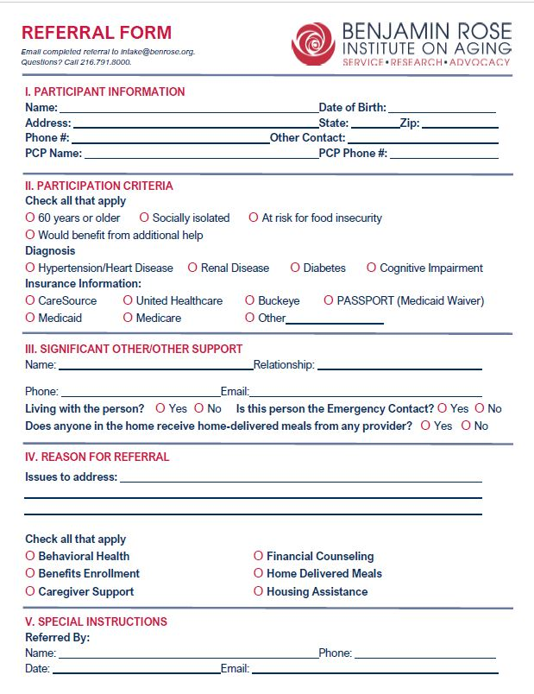

**Leave-behind “Calling Card”**

Here’s an example of what one agency has provided to other sites that have agreed to refer Care Consultation to their clients. It’s a simple business card that’s inexpensive to produce. The content is short, simple and to the point.

But it’s the photo of the Care Consultant that they believe is the key to its success. The ability for the caregiver or the care receiver to put a friendly face to the program is instrumental in encouraging them to call for the first appointment.

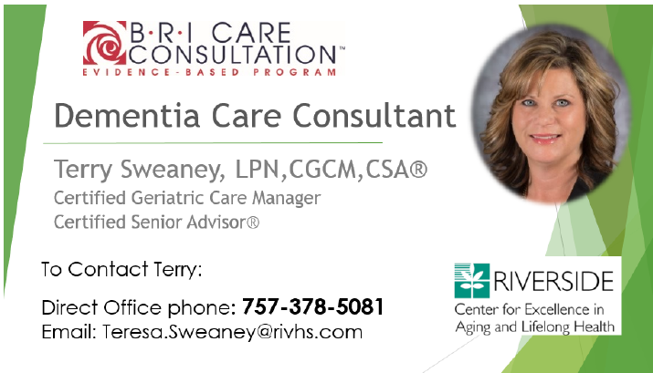

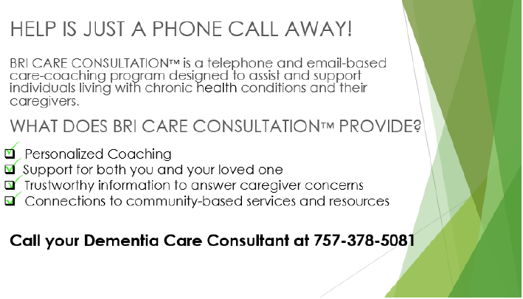

**Half-page flyer**

Sometimes it’s more convenient to stock a half-sheet of information that can be easily handed out, folded and transported. It contains key information without being overwhelming.

**Two-sided rack card**

This simple piece can be modified with your organization’s logo and contact information. The small size makes it ideal for handing out at events, providing to referral partners for distribution, and including in written outreach to potential partners and clients as it fits inside a standard business envelope.

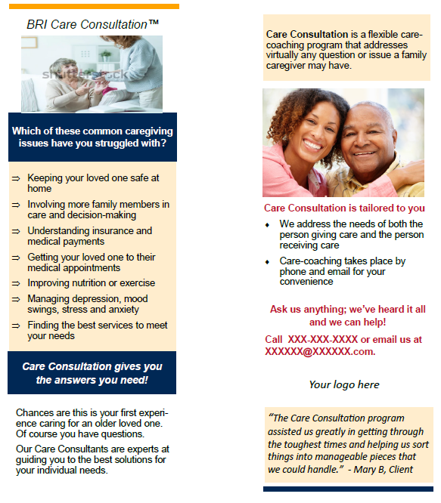

**Sample flyer for distribution**

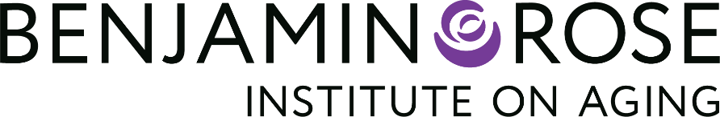

**BRI Care Consultation™** is a proven care-coaching solution delivered by telephone and email to adults with health conditions and their family or friend caregivers, empowering both to manage short- and long-term needs more effectively. It’s delivered by community and government organizations across the country, as well as the Benjamin Rose service delivery arm, called WeCare . . . Because You Do.SM

BRI Care Consultation uses a combination of ongoing assessment, action planning, and follow-up support to create real and lasting changes in the caregiving situation. Through numerous research studies, BRI Care Consultation has been proven to provide positive outcomes including reduced relationship strain, decreased depression and fewer ER visits.

**Benjamin Rose Institute on Aging** is a nonprofit organization that supports caregivers and empowers all people to age well through research, consumer-responsive services and client advocacy. We seek a world where everyone has resources to age well in places they choose, ageism is eliminated, and caregivers are provided with necessary supports.

For more information, please contact Michelle Palmer, [mpalmer@benrose.org](mailto:mpalmer@benrose.org).