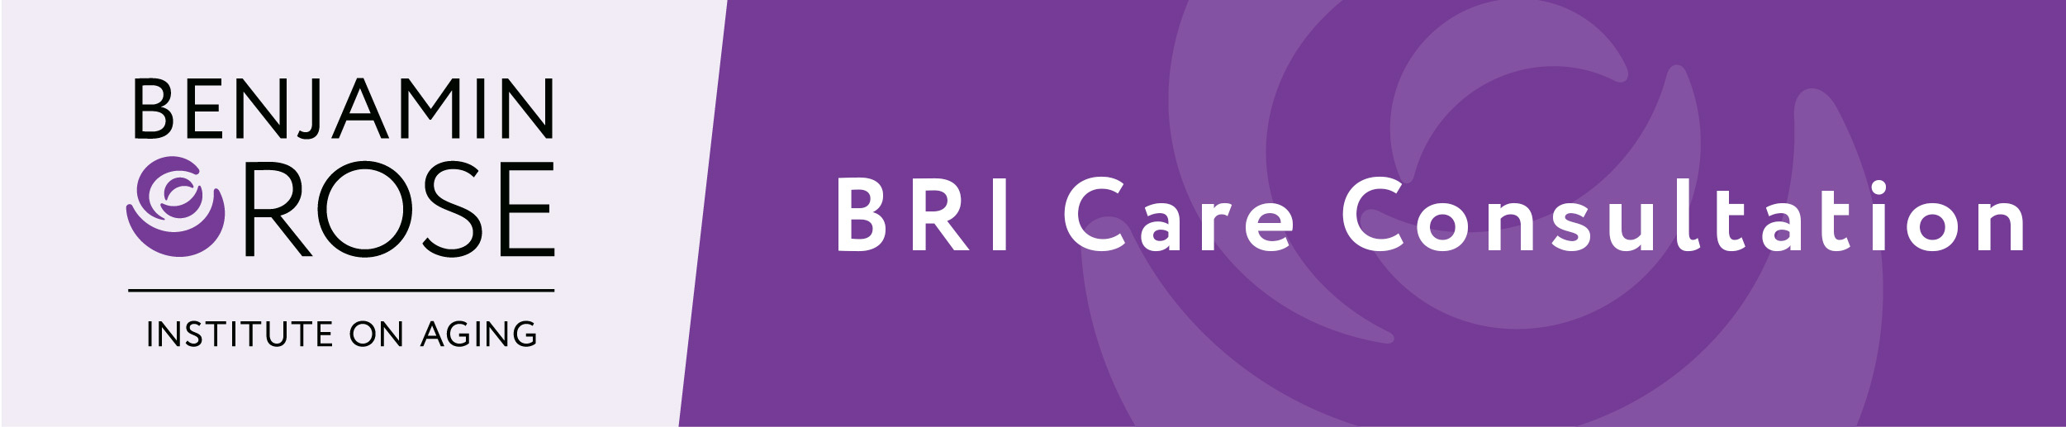

What is Care Consultation?

Caring for an older person in our lives is an act of love, but it also comes with challenges, questions and concerns. Care Consultation is a telephone-based program that helps you and the person you’re caring for find the resources and support you need, answer your questions, and solve the issues you may be facing.

What kind of issues will be addressed?

You can talk with your Care Consultant about any care issues you’re experiencing. Often addressed are finding services like transportation, respite or home-delivered meals, as well as guidance with insurance, finances and long-term living options. You will also discuss daily living issues, including dressing and bathing, eating, sleep, nutrition and managing challenging behaviors; your Care Consultant will match you with the education, training and strategies you need.

Who will I be talking to?

You’ll speak with a professional Care Consultant who is trained to provide quality information, organize help from family and friends, assist with finding and using community services, and suggest positive approaches to care. The same Care Consultant will provide follow-up calls and check-ins as you continue to work together.

Who participates in Care Consultation?
Family and friend caregivers of any age may enroll in the program. Typically, participants are caregivers who are feeling stressed or anxious about providing care, or are simply feeling overwhelmed. Many people appreciate that the program empowers caregivers to feel more confident in providing care, which eases some of the burden and stress, too.

How do I know if the program is right for me?
WeCare seeks to support anyone providing care for an older adult. Each caregiving situation is unique. We work alongside you to provide strategies and solutions that best meet your goals, help you develop next steps, and adapt to inevitable changes.

Do I have to go anywhere to receive services?
No. All communication is done by telephone, email or online at times that are convenient for you.

If I change my mind, can I stop participating?
You can stop using the program at any time. We will always welcome you back as your caregiving situation changes or you simply decide you would like more support.

Who should I contact with questions?

Please contact 216-123-4567 or email@organization.org.

