

Contents:
Identifying potential referral partners – Page 3
Approaching referral partners – Page 4
Keeping the relationship fresh – Page 6
Sample letters and emails – Page 7

The Secrets to a Successful Referral Program
The Secrets to a Successful Referral Program

One of the best strategies for bringing new caregivers into the BRI Care Consultation program is maintaining a strong referral program. Organizations that are most successful in delivering Care Consultation and similar caregiver support programs are those that enjoy an ongoing flow of new clients that are referred to them through internal or external healthcare resources, social service organizations, professional associations and community-based organizations that service similar populations.
Therefore, developing successful referral relationships is something that organizations delivering Care Consultation should certainly devote some time and attention to. Developing referral relationships can be a challenging process, though. They’re rarely achieved in a single mailing or phone call. In fact, there are a few things that sites looking to build strong referral relationships should keep in mind:
- Building successful referral relationships takes time!
- Referral relationships require personal contact with the other site or professional
- The relationship needs to be maintained and nurtured
- The referring organization needs to feel confident in recommending your program

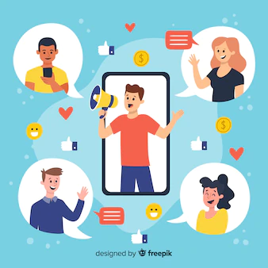

Build a successful strategy – target the right partners

The first step in planning your referral strategy is to target appropriate partners in your area. Make a list of healthcare or community organizations, social service and government agencies that service your desired population. Make this a priority; don’t stop at a few agencies you happen to know. Make the list as long as you can. They will likely include:

Healthcare facilities
- Hospital geriatric centers, neurology departments
- Hospital and rehabilitation discharge departments
- Screening and diagnostic facilities
- Geriatricians and general practitioners
- Private practice neurologists, oncologists, etc.
- Home health care agencies

Other groups:
- Caregiver support groups
- Area Agency on Aging offices
- State or regional offices on aging
- Alzheimer’s or other disease-specific associations
- Home delivered meal programs
- Sites offering exercise/diet/health education for older adults

Senior-focused facilities
- Senior day/activities centers
- Adult Day centers
- Assisted living facilities

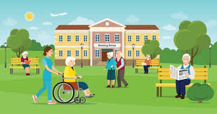
Approaching potential referral partners

After you’ve selected your organizations, spend a little time researching who to send your message to. Is it the Executive Director? Program Manager? Department Head? Spend a little time on their website and see what names you can find, along with email addresses and phone numbers.
Remember - a single contact is almost never enough. It may take several tries before the prospective partner is willing to talk to you. Just because they don’t respond to your first outreach doesn’t mean they’re not interested, perhaps just busy.

Modes of communicating
Email communication: Email is a highly acceptable form of soliciting business. In fact, many people prefer to communicate electronically. Of course, it often takes several tries to get someone to open and read an email.
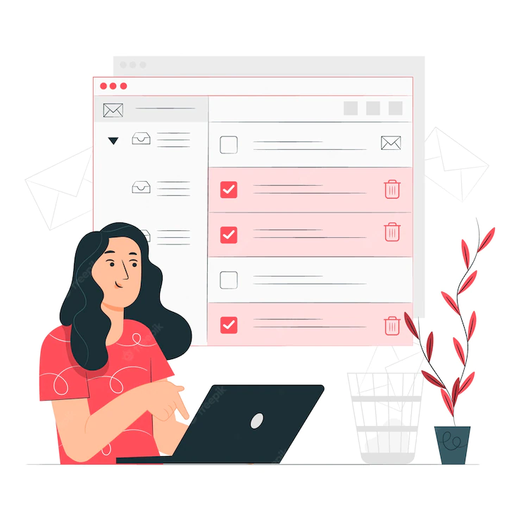
One of the benefits of email is to offer people with even moderate interest in your offer the opportunity to easily reply back to you. Make sure your email contains a simple and straightforward offer that they can accept with little effort – requesting your electronic program brochure is often very effective.
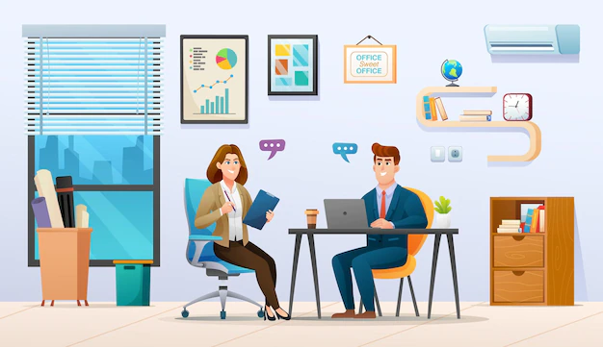
A personal visit: Of course, this is the most resource- and time-intensive method, but it’s also the most effective. You’ll want to use this technique with sites that offer the most potential referrals or where you have an existing relationship with staff members.


Telephone: It’s true that many people don’t especially like talking on the phone. But the phone is still a highly effective way to make contact with a new potential partner. It’s especially effective in following up on an email or letter that’s been sent. Even if the result is a voicemail, it still carries the benefit of adding a personal, friendly voice to your organization, and added attention to your message.

Letter: Especially with the massive decline in the volume of mailed correspondence, letters can actually be a highly effective tool for introducing your program to referral sources. Just be sure to make it short and to the point.
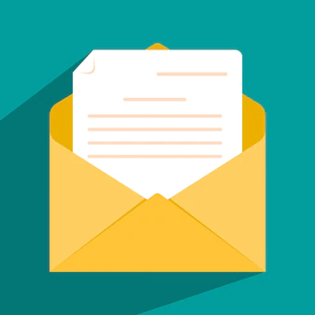
Personalize it to the individual receiving it. Put the letter on letterhead, sign it yourself, and put it in an envelope with a real stamp on it. Hand-writing the address on the envelope gets it opened even more often.

Postcard mailings: Postcards are a popular choice among many agencies because they’re easy to create, fairly low in cost and can be mailed in bulk at a lower rate. There’s also some value in the message being immediately visible without having to open an envelope.
Unfortunately, postcards have a poor response rate. They are rarely effective in being memorable enough to spur action and are frequently not taken seriously by the recipient. A personal letter typically generates more interest.



Keeping the relationship fresh

If your referral source is local, one of the best ways to keep your relationship fresh is to deliver goodies to the staff. (In fact, that may be the best way to deliver any message, any time! ) A personal visit with a thoughtful snack is always appreciated.

But it’s not always feasible to visit your referral partners. But you can still maintain written or telephone communication with them to show your appreciation and keep your services top of mind.

Ask staff members or agency leaders to participate as a speaker or on a panel in your next educational session, webinar or lunch & learn. Getting them more involved in your organization can only help to solidify their commitment to your programs


Send them useful articles or videos you’ve identified that they may find interesting or helpful, like new research studies, news about local organizations, etc.

Share with them a success story about a client they referred to you. Nothing speaks louder than real impact.

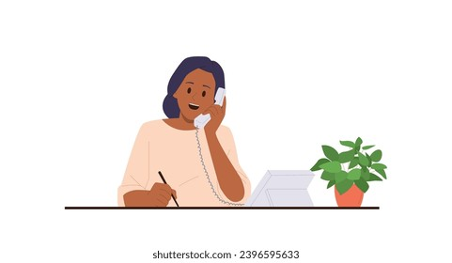
Give them a call and thank them. Refer to a specific referral who is flourishing in your program You may get voicemail, but that’s fine. Who wouldn’t want to be on the receiving end of a positive message like that?

Samples: Cold Referral Requests - Email or mail
Dear Bob,
It seems to me that there’s a significant crossover in our client populations, and I’m wondering if it might make sense for us to talk about establishing some sort of a referral relationship.
We are (organization name) and we offer a caregiver support program to family members who are providing care to a loved one, as well as support to the older adults receiving care. Care Consultation is an evidence-based care-coaching program, conveniently delivered by telephone and email, that has been proven to help the care partners decrease their levels of stress and depression and improve the care environment in meaningful ways.
Do you think our program might be of benefit to your clients (residents, members)? If so, I’d love to start a dialogue about how we may be able to work together to share resources.
Please feel free to email me back or give me a call at xxx. You can find more information about Care Consultation here (link to website or brochure). Thanks for your time, I look forward to speaking with you soon.
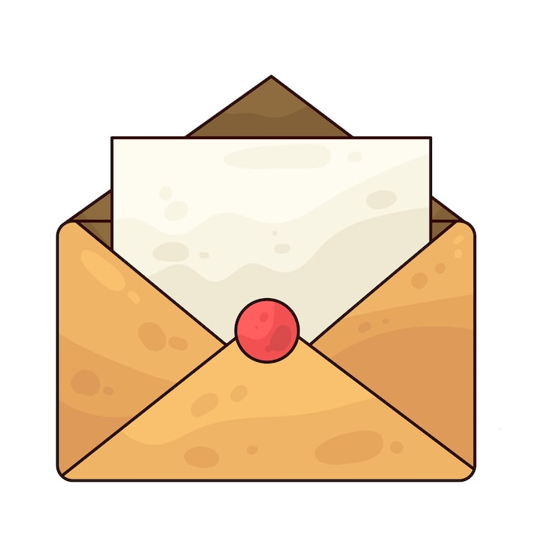
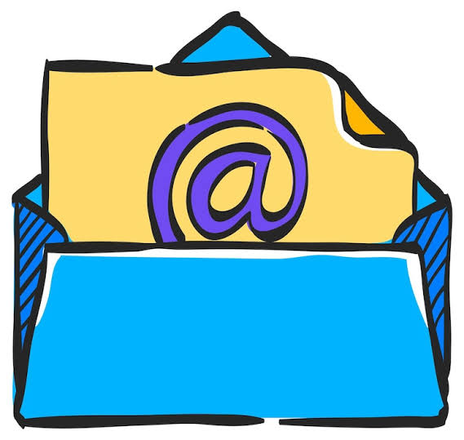

Dear Sue,
Do you think your clients would benefit from a care-coaching program that helps family caregivers of older adults (living with dementia) improve their care environment in meaningful ways?
Care Consultation is a convenient, remotely-delivered evidence-based program that helps family and friend caregivers find helpful resources, access useful information to manage insurance and financial issues, and relieve some of their burden to decrease stress, depression and feelings of isolation. We deliver the program free of charge.
If you think a program like would be of value to your clients, I’d love to speak with you about opportunities to make them aware of our services.
Please feel free to email me back or give me a call at xxx. You can find more information about Care Consultation here. Thank you for your time, and I look forward to speaking with you soon.

Sample Home Health Agency referral request: Email

Help your clients manage their home care situation – even when you’re not there
Care Consultation from (organization name) is a convenient telephone and email-based program designed to help improve the family care environment by addressing the needs of both the family caregiver and the person living with a chronic illness, including Alzheimer’s and dementia.
Care Consultation can help improve care
Families providing care to a loved one face many challenges they’re not prepared for. When you refer your clients to Care Consultation, you’re providing them with a valuable resource that helps them address their most pressing unmet needs, find resources to help solve problems, answer their questions and give them the support they need. Care Consultation:
- Helps older adults remain in their homes longer
- Deepens the care relationship with your clients
- Identifies other needs related to health care concerns
- Enables aides to focus on necessary care tasks
- Increases overall satisfaction with your services
- Has been proven to reduce hospital readmissions and ER visits
- Provides information and advice on what matters most to families caring for an older adult

Care Consultation offers proven results
Through multiple research studies, Care Consultation has been shown to reduce caregiver stress, decrease strain on the relationship, and decrease symptoms of depression in both the caregiver and the person living with dementia.

Feel free to contact me (name and organization) for more information on how your Home Health Agency can refer this important program to your clients in need.

Sample – Home Health Agency referral request
Personal email or letter

Dear Ben,
As your Home Health Professionals visit patients and family caregivers in their homes, it’s likely they encounter families struggling to provide effective care to an older loved one living with dementia. (Organization name), a (description of organization), offers an innovative care-coaching program that provides much-needed support, resources and solutions for both family caregivers and for people living with chronic illnesses or Alzheimer’s disease.
Through grant funding, we’re able to offer this service free of charge to participants in (area), and we would be pleased to partner with you in helping to spread the word about this life-changing service to your clients, along with family caregivers who may be struggling to provide the care that’s needed.
To help you feel more comfortable in recommending our proven program, I would be happy to provide you and your staff with an overview of Care Consultation, how we deliver the program, and why it’s so effective in helping to improve the care dynamic for older adults and their caregivers.
Please let me know if you’re interested in learning more about our care-coaching program. I’m at (number) or (email) and I look forward to speaking with you soon.


Sample Email – Health System

Dear Dr. Smith,

Have you noticed all the talk these days about "comprehensive dementia care" and "community care navigation?" It's wonderful that these important concepts are finally getting the attention they deserve.

Many health systems across the country and launching Community Care Navigation programs, often in partnership with community-based organizations, which help them to address the estimated 80% of healthcare that happens outside medical facilities.

Our organization (name) is partnering with healthcare facilities to help extend caregiver and care receiver supports to their patients. Our evidence-based BRI Care Consultation program delivers person-centered care by assessing 35 different areas of potential need for both the caregiver and the person receiving care. Equally important, the program provides a proven framework and system protocols that guide effective delivery and assure comprehensive care. You can visit our website for more details on this versatile program.

Our program has been proven in 12 research studies to decrease unmet needs and reduce caregiver burden. Our experienced Care Navigators help caregivers find the community resources they need, provide education, skills training and emotional support – all at no cost to the family.

I'd like to invite you to join us for an online meeting to discuss the full meaning of care navigation, and learn more about BRI Care Consultation and how it addresses the needs of older adults and family caregivers. Please feel free to let me know your availability or to request additional information.
